Code churn: A neglected metric in effort-aware
Just-In-Time defect prediction

Department of Computer Science and Technology, Nanjing University

Abstract—A recent study by Yang et al. leveraged individual change metrics to build unsupervised Just-in-Time (JIT) defect prediction model. They found that many unsupervised models perform similarly to or better than the state-of-the-art supervised models in effort-aware JIT defect prediction. However, Churn as the most important change size metric was not used for evaluating unsupervised models. In this study, consistent with Yang et al., we first use Churn to build an unsupervised model. Then, we evaluate the prediction performance of the churn based unsupervised model against the state-of-the-art supervised and unsupervised models under the following three prediction settings: Cross-validation, time-wise cross-validation, and cross-project prediction. Based on six open-source projects, our experiment results show that the churn based unsupervised model performs better than all the state-of-the-art supervised and unsupervised models. The result suggests that future JIT defect prediction research should use churn based unsupervised model as the baseline model for comparison when a novel model is proposed.
Keywords—Defect, prediction, changes, just-in-time, code churn, unsupervised models, supervised models

Introduction
Software defect prediction techniques are developed for predicting defects in software systems. They can play an important role in producing high quality software. However, most prior research studies on defect prediction are at module level [3, 4, 7, 8, 10, 11, 12]. A module could be a package or a file. In module-level defect prediction, developers still have to spend considerable time drilling down to review or test those identified defect-prone modules. Therefore, recent years have seen an increasing research effort devoted to just-in-time (JIT) defect prediction. The JIT defect prediction aims to predict the probability of changes to be defect-inducing changes. A defect inducing-change is a software change that introduces one or several defects into a software system. Compared with prior studies, JIT defect prediction is at fine granularity. According to Kamei et al. [5], the JIT defect prediction allows developers to inspect the code changes for finding the defects when the design details are still fresh in their minds. Since changes in JIT defect prediction could be small code areas, it might provide effort savings over coarser grained predictions.
Kamei et al. [5] introduced the concept of effort-aware into JIT defect prediction. Based on linear regression, they build a supervised JIT defect prediction model EALR. They found that using only 20% effort it would take to inspect all changes, the EALR model can identify 35% defect-inducing changes. Recently, Yang et al. [9] leveraged individual change metrics to build unsupervised JIT defect prediction model. They found that many unsupervised models perform similarly to or better than the state-of-the-art JIT supervised defect prediction models.
However, in Yang et al.’s study, Churn as the most basic change size metric was not used to build unsupervised model for the evaluation. In prior studies on defect prediction, code size based model was often used as a baseline model for a comparison [?]. Therefore, in this study, consistent with Yang et al., we first use Churn to build an unsupervised JIT defect prediction model. Then, we evaluate the prediction performance of Churn-based unsupervised models against the state-of-the-art supervised and unsupervised models under the same three prediction settings as Yang et al.: cross-validation, time-wise cross-validation, and cross-project prediction.
The main contributions of this paper are summarized as follows:
(1) We probe into the predictive effectiveness of unsupervised and supervised models in the context of effort-aware JIT defect prediction, and find Churn can be an unsupervised model.
(2) We conduct an in-depth investigation on the prediction performance on the Churn-based unsupervised JIT defect prediction models. leverage the code churn to build unsupervised JIT defect prediction model, compare code churn with the state-of-the-art supervised models [5,29] in recent literature and Yang’s simple unsupervised models [9]. The experiment results show that our novel approach can achieve a better performance than all of them.
The rest of this paper is organized as follows. Section 2 introduces the background of defect prediction. Section 3 describes the research questions of this paper. Section 4 provides the experimental setup in our study, including the data sets, prediction settings, performance indicators and data analysis method. Section 5 reports in detail the experimental results. Section 6 examines the threats to validity of our study. Section 7 concludes the paper and outlines directions for future work.

BACKGROUND
In this section, we first introduce the background on supervised and unsupervised defect prediction models. Then, we describe related works on effort-aware JIT defect prediction.

A. Supervised VS unsupervised models
From a theoretical point of view, supervised and unsupervised models differ only in the causal. The supervised model defines the effect one set of observations, called training set, has one another set of observations, called testing set. The training set is assumed to be at the beginning and testing sets at the end of the causal chain. While in unsupervised model, all the observations are assumed to be caused by latent variables. Fig. 1 provides an overview of the causal structure and the difference is illustrated. In practice, models for supervised learning often leave the probability for training sets undefined. But if some values ( mainly the labels which are used as a judgment ) of the training sets are missing, it is not possible to infer anything about the testing sets. That is to say, supervised defect prediction models cannot be built if the defect data are unavailable. This is especially true when a new type of projects is developed or when historical defect data have not been collected. However if the training sets are also modeled, the missing labels cause no problem since they can be considered latent variables as unsupervised model.
As the supervised model try to find the connection between two sets of observations, with supervised learning, it is possible to learn smaller and less complex models than with unsupervised learning. The difficulty of the learning task increases exponentially in the number of steps between the two sets , so the supervised learning cannot learn models with deep hierarchies, while unsupervised learning can do.[15]
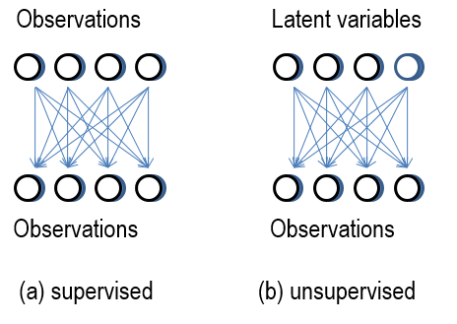
Fig. 1. The causal structure of (a) supervised and
(b) Unsupervised model
In the last decades, supervised models have ever been widely used in traditional defect prediction at module (e.g. file or class) level [1,2,5,20,23,25,27,28,30]. In a supervised model, the defect data such as the number of defects or the labeled information (buggy or not-buggy) for each module is needed, although, for practitioners, it may be not easy to collect them, not only because of the time-consuming work, but also the validity of the collecting labels[17].
Compared with the essential in supervised models, the defect data do not needed in unsupervised models. Due to this advantage, an increasing time and effort is devoted into the unsupervised modeling techniques to build defect prediction models [3,16,18, 25].
Prima facie, there are good reasons to suppose that the result of unsupervised models may be not as good as supervised models, because the building of unsupervised models is easier and more convenient , however Yang et al.’s study [9] showed it is not the case.

B. Just-in-time defect prediction
The template is used to format your paper and style the text. All margins, column widths, line spaces, and text fonts are prescribed; please do not alter them. You may note peculiarities. For example, the head margin in this template measures proportionately more than is customary. This measurement and others are deliberate, using specifications that anticipate your paper as one part of the entire proceedings, and not as an independent document. Please do not revise any of the current designations.
The origin of JIT (just-in-time) defect prediction can be traced back to Mockus and Weiss [20]. They used a number of change metrics to predict whether a change is a defect-inducing change.
Compared with traditional defect predictions at module level, JIT defect prediction can narrow down the checking area and shorten working time. A more beneficial factor, JIT can make it easier to find the code developer, and he or she has the fresh mind of the change very likely because of the convenience of space and time.
Follow Mockus and Weiss’s study, there is an increasing interest in JIT defect predictions from the last decade. Besides the research we have mentioned before, Śliwerski et al. [21] examined the properties of fix-inducing changes in the ECLIPSE and MOZILLA projects and found, among others, that the larger a change, the more likely it is to induce a fix. Eyolfson et al. [21] studied the correlation between a commits bagginess and the time of day of the commit, the day of week of the commit, and the experience and commit frequency of the commit authors, through surveying two widely-used open source projects: the Linux kernel and PostgreSQL. Yin et al. [22] presented one of the most comprehensive characteristic studies on incorrect bug-fixes from large operating system code bases, studied the common patterns of mistakes made in incorrect fixes that can be used to alert the programmers as well as to design detection tools to catch incorrect fixes, and studied the code knowledge of developers , found that 27% of incorrect fixes were made by developers who had not contributed a single line to the entire file they were about to fix. Kim et al..
Kamei et al. [5] not only took the viewpoint, but also applied effort-aware evaluation in JIT defect predictions [5]. In their study, churn, which is defined as the total number of lines modified, is used as a measure of the effort required to inspect a change, and a linear regression method is used to build the effort-aware JIT defect prediction model (called the EALR model). In EALR, Y(x)/Effort(x) is acted as the dependent variable, where Effort(x) was the effort required for inspecting the change x and Y(x) was 1 if x was defect inducing and 0 otherwise. In their results, 35% of all defect-inducing changes can be detected , while inspecting 20% of the effort. As such, Kamei et al. made conclusion that effort-aware JIT defect prediction was able to focus on the most risky changes and reduced the costs of developing high-quality software.
Yang et al. [29] applied ensemble learning into JIT defect prediction, their approach could be seen as a two-layer ensemble learning (TLEL) technique. In the inner layer, bagging based on decision tree is used to build a random forest model. In the outer layer, stacking is used to ensemble many different random forest models. Yang et al. compared TLEL with three baselines, i.e., Deeper [26], DNC [24], and MKEL [19]. The experimental results showed that on average TLEL could discover over 70% of the bugs by reviewing only 20% of the lines of code, as compared with about 50% for the baselines.
Yang et al. [9] performed an empirical study to investigate the predictive power of simple unsupervised models in effort-aware JIT defect prediction. In particular, contrary to the general expectation, Yang et al. [9] found that several simple unsupervised models performed better than the state-of-the-art supervised model reported by Kamei et al. [5], include EALR.
Fu et al. [32] challenged Yang et al.’s study [9], they found that not all unsupervised learners work better than supervised learners on all six data sets for different evaluation measures. They investigated how to pick the best models before deploying them to a project, and put forwarded an OneWay learner, which is supervised learner built on the idea of simple unsupervised learner.
Yang et al.’s study [9] compared with Kamei et al.’s work [5] directly, they both used P_{opt} and ACC as evaluation metrics to evaluate the performance of their approach, as well Fu et al.’s study [32]. While Yang et al.’s TLFL [29] took PofB20 and F1 as performance indicator. Fortunately, the three studies [5,9,29] used the same six industrial-size systems: Bugzilla, Columba, Eclipse JDT, Eclipse Platform, Mozilla and PostgreSQL.

EXPERIMENTAL SETUP
In this section, we first give the research questions. Data sets which we used in our experiments are introduced secondly. Then, for evaluating the effectiveness of defect prediction models in effort-aware JIT defect prediction, performance indicators are provided. After that, our data analysis method is described.

Research questions
We investigate the following three research questions to determine the practical value of code churn models:
- RQ1: How well do code churn models predict defect-inducing changes when compared with Kamei et al.’s supervised model EALR [5]?
- RQ2: How well do code models predict defect-inducing changes when compared with the Yang et al.’s supervised model TLEL [29]?
- RQ3: How well do code churn models predict defect-inducing changes when compared with the single unsupervised models and Fu et al.’s supervised model OneWay?
- RQ4: How well do code churn models predict defecting changes when compared with Yang et al.’s unsupervised models?
The purposes of RQ1, RQ2, and RQ3 are to compare Churn-based unsupervised JIT prediction models with four studies [5, 29, 9,32] ，so that we can determine how well the code churn predict defect-inducing changes in JIT defect prediction. Kamei et al.’s EALR [5] , Yang et al.’s TLEL [29] and Fu et al.’s OneWay almost represent the latest and most sophisticated entry in the family of supervised JIT defect prediction models, combining the RQ1 and RQ2 is to compare code churn with supervised models, while RQ3 is to unsupervised models and supervised model.

Data sets
In this study, the three studies use the same open-source subject projects, they are: Bugzilla (BUG), Columba (COL), Eclipse JDT (JDT), Eclipse Platform (PLA), Mozilla (MOZ), and PostgreSQL (POS). In order to facilitate comparison, we test code churn with these datum.
TABLE I. Summarize of the six data sets
Sys | First | Last | bugs | #changes | ratio
BUG | 1998/8/26 | 2006/12/16 | 1696 | 4620 | 36.71
COL | 2002/11/25 | 2006/07/27 | 1361 | 4455 | 30.55
JDT | 2001/05/02 | 2007/12/31 | 5089 | 35386 | 14.38
MOZ | 2000/01/01 | 2006/12/17 | 5149 | 98275 | 5.24
PLA | 2001/05/02 | 2007/12/31 | 9452 | 64250 | 14.71
POS | 1996/07/09 | 2010/05/15 | 5119 | 20431 | 25.06
Table I summarizes the six data sets used in this study. The first column is respectively the project name, the second column and the third column are the period of time for collecting the changes. The forth is the count of bugs, the fifth is the number of commit changes, and the last column is the ratio of bugs, defined as: ratio=bugs /changes.
In Kamei et al's work [5], all OSS data sets are provided, the metrics are summarized in Table II, metrics and their definitions are listed. The data is grouped into seven dimensions.
The Transaction of a change shows the serial number and the Commitdate shows the commit time and date. This dimension is used to sort the records in Yang et al’s [9] experiment of time-wise cross validation ,which will be described in data analysis method.
The Bug is the posted bug information which shows a binary number, we use this factor as dependent variable in this study.
The other 5 dimension, 14 factors are used as the independent variables, for they perform well in traditional defect prediction research, and they are used in all the three studies [5, 9, 29, 32].
TABLE II. Summarization of change metrics
Dimension | Metric | Description
Diffusion | NS | Number of subsystems touched by the current change
Diffusion | ND | Number of directories touched by the current change
Diffusion | NF | Number of files touched by the current change
Diffusion | Entropy | Distribution across the touched files, i.e.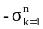, where n is the number of files touched by the change and p_{k} is the ratio of the touched code in the k-th file to the total touched code by the change
Size | LA | Lines of code added by the current change
Size | LD | Lines of code deleted by the current change
Size | LT | Lines of code in a file before the current change
Purpose | FIX | Whether or not the current change is a defect fix
History | NDEV | The number of developers that changed the files by the change
History | AGE | The average time interval (in days) between the last and the change over the files that are touched by the current change
History | NUC | The number of unique last changes to the files by the current change
Experience | EXP | Developers experience, i.e. the number of changes
Experience | REXP | Recent developer experience, i.e. the total experience of the developer in terms of changes, weighted by their age (in years)
Experience | SEXP | Developer experience on a subsystem, i.e. the number of changes the developer made in the past to the subsystems touched by the change
Bug | Bug | Whether the change is a bug

Performance indicators
In order to verify the effect of the experiment, we adopted the standard of measurement which is consistent with the original three studies.
In Kamei et al.’s [5] , Yang et al.’s [9], and Fu et al.’s [32] studies, ACC and Popt are acted as two evaluation metrics to evaluate the performance of their approach. Kamei et al. took all of the changes that they could review with just 20 percent effort off the list and counted how many defects these changes would contain. Recall is the ratio of correctly predicted defect-inducing changes to the actual defect-inducing changes, defined as Recall= TP/(TP+FN), where TP is those correctly classified as defect-inducing changes, and FN is those falsely classified as non-defect-inducing changes. ACC denotes the recall of defect-inducing changes when using 20% of the entire effort required to inspect all changes to inspect the top ranked changes. The effort use the term of code churn, defined as churn=LA+LD, where LA is the added lines and LD is the lines of code deleted.
Fig. 2 is a diagram showing the performance indicator of P_{opt.} In this diagram, the x-axis and y-axis are respectively the cumulative percentage of code churn of the changes (i.e., the percentage of effort) and the cumulative percentage of bugs found in selected changes. To compute P_{opt}, two additional curves are included: the “optimal” model and the “worst” model. In the “optimal” model, changes are sorted in decreasing order according to their actual defect densities. In the “worst” model, changes are sorted in ascending order according to their actual bug densities. According to [5], P_{opt} can be formally described as: P_{opt}(m)=1-(Area(Optimal)-Area(m))/(Area(Optimal)-Area(Worst)).

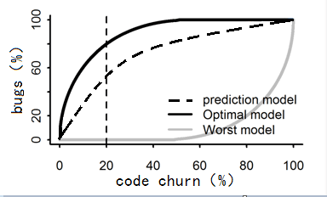
Fig.2 Performance indicator of P_{opt}
Here, Area (optimal) and Area (worst) is the area under the curve corresponding to the best and the worst model, respectively. Note that both ACC and Popt are applicable to supervised models as well as unsupervised models.
PofB20 and F1 are used to evaluate TLEL performance in Yang et al.’s work [29]. PofB20 is actually cost effectiveness when reviewing percentages of 20% lines of code. Cost effectiveness is measured by computing the percentage of buggy changes found when reviewing a specific percentage of the lines of code. To compute cost-effectiveness, firstly a number of changes are given, then sorted according to their output scores, then are simulate to be reviewed one-by-one from the highest ranked change to the lowest ranked change and record buggy changes found. Using this process the percentage of buggy changes are found when reviewing different percentages of lines of code (1% to 100%).
F1 is a commonly-used measure to evaluate classification performance. It combines Precision and Recall and can be derived from a confusion matrix. The confusion matrix lists all four possible prediction results. If an instance is correctly classified as “buggy”, it is a true positive (TP); if an instance is misclassified as “buggy”, it is a false positive (FP). Similarly, there are false negatives (FN) and true negatives (TN). Based on the four numbers, Precision, Recall and F1-score are calculated. Precision is the ratio of correctly predicted “buggy” instances to all instances predicted as “buggy” (Precision = TP/(TP+FP )). Recall is the ratio of the number of correctly predicted “buggy” instances to the actual number of “buggy” instances (Recall = TP/(TP+FN )). Finally, F1-score is a harmonic mean of Precision and Recall: F1-score = 2 * Recall * Precision / (Recall + Precision). F1-score is often used as a summary measure to evaluate if an increase in precision outweighs a reduction in recall (and vice versa).
To control the false discover rate, we used the Benjamini-Hochberg (BH) adjusted p-value to test whether two distributions are statistically significant, which corresponds to a p-value of less than 0.05 [9, 32, 33]. To measure the effect size of performance scores among the supervised and unsupervised models, we compute Cliff’s delta, if cliff’s delta is bigger than 0.474, that means large [32, 34].

Data analysis method
Kamei et al. [5] used a logistic regression model to perform their prediction .The logistic regression model outputs a probability, i.e., a value between 0 and 1, for each change. They used a threshold value of 0.5, which means that if the model-predicted probability of a defect is greater than 0.5, the change is classified as defect inducing; otherwise, it is classified as non-defect-inducing.
Yang et al.’s [9] analysis method consists of three parts: 10 times 10-fold cross-validation, time-wise-cross-validation, and across-project prediction.
10 times 10-fold cross-validation is performed in each project. At each time, the data set is divided to 10 parts of approximately equal size after randomized. Each part will be used as the testing set and all the others be training set. Hence 100 prediction values of a model will be got. Through multiple tests, as far as possible to show the performance of the various models. Each time can be regarded as independent, and all results are taken on average. Yang et al. [29] also used the 10-fold cross-validation in their experiment.
Time-wise-cross-validation is also performed within the same project. Compared with 10 times 10-fold cross-validation, there are two giant difference. Firstly all the changes are sorted by the commit time, followed the method of [21]. For each project, the changes in chronological order according to the commit date, are grouped into the same part within the same month. Secondly the testing set is not immediately following the training set, i.e. There is a gap between the two sets. For example, As Fig. 3 shows, the training set is the data from fold i to fold i+k, while the testing set is the data from fold i+k+gap to fold i+k+gap+k, where k is the number of month( In Yang’s study [9], k is initialized to 2). Ming Tan et al. [31] found that bugs typically take years to be discovered and fixed ,therefore, at the prediction time fold i, many buggy changes in the training set, especially the changes committed close to time (such as fold i+k+1), would not have been found and fixed yet. Fu et al. [32] carried this prediction setting on their experiment.
Across-project prediction is performed across different projects. One project acts as a training set , another one acts as the testing set [27, 6]. Therefore, each prediction model will produce 6 × (6 − 1) = 30 prediction effectiveness values.
Yang et al.’s study [29] also used the 10 times 10-fold cross-validation, TLEL can be refined as the following steps:
- Extract features (as shown in Table 2) from training changes ;
- Normalized features with Z-score method as: zi=fi-mean(f)/std(f);
- Under-sampling to handle the class in balance problem;
- Construct the base leaners based on decision;
- The ensemble classifier is used to predict.
Kamei et al. [5] and Yang et al. [9] posted their source code in network, so we can repeat their work. We repeat Kamei et al.’s EALR[5], get the same result. We repeat Yang et al.’s study [9] with three prediction settings , not only to get the same result of their work, but also to check code churn in these different settings. For we haven’t got Yang et al.’s [29] and Fu et al.’s [32] programming code , we can’t repeat the experiment of TLEL ,nor OneWay, either. To compare TLEL and OneWay with code churn, we only analysis through data in their paper.

EXPERIMENTAL RESULTS
In this section, we report the experimental results in detail.

RQ1: How well do Churn-based unsupervised model predict defect-inducing changes when compared with Kamei et al.’s supervised model EALR [5]?
As described in data analysis method, We use Yang’s [9] three prediction settings to test and verify code churn in JIT defect prediction.
Table 3 described the result of ACC and Popt in 10-fold cross-validation. In 10-fold cross validation, 100 predict values of each project are got, Data in the corresponding cell is the average value and the average standard deviation. In order to make the comparison appear more obvious, we put the winning data in bold font. As shown in Table 3, whether ACC or Popt , unsupervised model churn is much better than EALR. The random predictor of ACC is 0.2 (i.e., the percentage of detected defect-inducing changes to all defect-inducing changes when using 20 percent of all effort), and the random predictor of Popt is 0.5, so Kamei’s EALR just make the prediction (0.292, 0.554) a little bit better than the random model. Comparing to random model, churn can improve ACC 269%=(0.738-0.2)/0.2, improve P_{opt} 78.6%=(0.893-0.5)/0.5.
Table III also presents the cliff’s deltas and p-value of code churn compared with EALR for each of the six data sets. The cliff’s deltas are all 1(means Large) , and P-value are all far less than 0.05. So in terms of ACC and P_{opt}, code churn improves the performance of the EALR statistically significantly and substantially in all data sets.
TABLE III. The result of ACC and P_{opt} in 10-fold cross-validation
Indic | Project | EALR | CHURN | Cliff | P-value
ACC | BUG | 0.407±0.110 | 0.782±0.049 | 1 | <0.001
ACC | COL | 0.414±0.099 | 0.810±0.080 | 1 | <0.001
ACC | JDT | 0.215±0.103 | 0.719±0.088 | 1 | <0.001
ACC | MOZ | 0.148±0.025 | 0.603±0.024 | 1 | <0.001
ACC | PLA | 0.289±0.072 | 0.749±0.060 | 1 | <0.001
ACC | POS | 0.271±0.065 | 0.705±0.068 | 1 | <0.001
ACC | Mean | 0.291±0.079 | 0.728±0.061 | ― | ―
Popt | BUG | 0.722±0.061 | 0.930±0.015 | 1 | <0.001
Popt | COL | 0.605±0.079 | 0.937±0.024 | 1 | <0.001
Popt | JDT | 0.514±0.098 | 0.879±0.033 | 1 | <0.001
Popt | MOZ | 0.453±0.02 | 0.813±0.013 | 1 | <0.001
Popt | PLA | 0.549±0.025 | 0.888±0.023 | 1 | <0.001
Popt | POS | 0.517±0.066 | 0.902±0.021 | 1 | <0.001
Popt | Mean | 0.560±0.058 | 0.891±0.022 | ― | ―

TABLE IV. The result of ACC and P_{opt} in time-wise cross-validation
Indic | Project | EALR | CHURN | Cliff |  | P-value
ACC | BUG | 0.306±0.211 | 0.697±0.181 |  | 0.835 |  | <0.001
ACC | COL | 0.400±0.145 | 0.720±0.129 |  | 0.932 |  | <0.001
ACC | JDT | 0.330±0.134 | 0.637±0.109 |  | 0.915 |  | <0.001
ACC | MOZ | 0.180±0.130 | 0.582±0.095 |  | 0.941 |  | <0.001
ACC | PLA | 0.305±0.158 | 0.704±0.119 |  | 0.949 |  | <0.001
ACC | POS | 0.345±0.162 | 0.615±0.166 |  | 0.838 |  | <0.001
ACC | Mean | 0.311±0.157 | 0.659±0.133 |  | ― |  | ―
Popt | BUG | 0.600±0.197 | 0.909±0.075 | 0.917 |  | <0.001
Popt | COL | 0.619±0.143 | 0.907±0.065 |  | 0.970 |  | <0.001
Popt | JDT | 0.588±0.113 | 0.837±0.052 |  | 0.958 |  | <0.001
Popt | MOZ | 0.498±0.112 | 0.802±0.045 |  | 0.959 |  | <0.001
Popt | PLA | 0.583±0.111 | 0.868±0.050 |  | 0.984 |  | <0.001
Popt | POS | 0.600±0.145 | 0.866±0.079 |  | 0.899 |  | <0.001
Popt | Mean | 0.582±0.137 | 0.865±0.061 |  | ― |  | ―
10-fold cross-validation randomizes the changes, while time-wise cross-validation sorts the changes in chronological order . In fact，we can hypothesize the committed changes have relation , maybe a change need to be fixed more than several times. To shed light on the hypothesis, Table 4 shows the result in the setting of time-wise cross-validation， cliff delta and p-value are provided at the same time. It is obviously , in contrast to the EALR, code churn still have an absolute advantage , no matter in the indicator of ACC or in P_{opt}.
Table V shows the result of across-project. One project acts as testing set, and each of others acts as the training set. Hence, 6 project provides 30 results. To attract attention, we still bold the font whose value is bigger than the other model .Obviously, code churn get the overwhelming advantage over EALR. Taking EALR as benchmark, code churn’s P-value and cliff’s delta show the more rigorously assessing, and the three prediction setting have the same conclusion.
TABLE V. EALR vs Churn in cross-project prediction
Train | Test | ACC |  | P_{opt}
Train | Test | EALR | CHURN | EALR | CHURN
BUG | COL | 0.497 | 0.836 | 0.701 | 0.948
BUG | JDT | 0.281 | 0.761 | 0.592 | 0.897
BUG | MOZ | 0.219 | 0.605 | 0.563 | 0.813
BUG | PLA | 0.429 | 0.774 | 0.695 | 0.899
BUG | POS | 0.349 | 0.726 | 0.603 | 0.908
COL | BUG | 0.336 | 0.79 | 0.633 | 0.932
COL | JDT | 0.113 | 0.761 | 0.418 | 0.897
COL | MOZ | 0.148 | 0.605 | 0.476 | 0.813
COL | PLA | 0.239 | 0.774 | 0.506 | 0.899
COL | POS | 0.167 | 0.726 | 0.426 | 0.908
JDT | BUG | 0.376 | 0.79 | 0.674 | 0.932
JDT | COL | 0.378 | 0.836 | 0.564 | 0.948
JDT | MOZ | 0.168 | 0.605 | 0.502 | 0.813
JDT | PLA | 0.277 | 0.774 | 0.555 | 0.899
JDT | POS | 0.299 | 0.726 | 0.514 | 0.908
MOZ | BUG | 0.35 | 0.79 | 0.619 | 0.932
MOZ | COL | 0.247 | 0.836 | 0.482 | 0.948
MOZ | JDT | 0.057 | 0.761 | 0.367 | 0.897
MOZ | PLA | 0.173 | 0.774 | 0.414 | 0.899
MOZ | POS | 0.135 | 0.726 | 0.382 | 0.908
PLA | BUG | 0.367 | 0.79 | 0.685 | 0.932
PLA | COL | 0.363 | 0.836 | 0.564 | 0.948
PLA | JDT | 0.152 | 0.761 | 0.458 | 0.897
PLA | MOZ | 0.168 | 0.605 | 0.498 | 0.813
PLA | POS | 0.23 | 0.726 | 0.478 | 0.908
POS | BUG | 0.351 | 0.79 | 0.629 | 0.932
POS | COL | 0.439 | 0.836 | 0.617 | 0.948
POS | JDT | 0.159 | 0.761 | 0.459 | 0.897
POS | MOZ | 0.159 | 0.605 | 0.497 | 0.813
POS | PLA | 0.261 | 0.774 | 0.544 | 0.899
Average |  | 0.263 | 0.749 | 0.537 | 0.9
P-value |  | <0.001 | ― | <0.001 | ―
Cliff's δ |  | 1(L) | ― | 1(L) | ―
Summary of the above three prediction settings , we can easily find that unsupervised model code churn has obvious advantages over EALR. Code churn achieve a substantial and statistically significant improvement over the supervised model EALR.

RQ2: How well do Churn-based unsupervised model predict defect-inducing changes when compared with the Yang et al.’s supervised TLEL model?
Yang et al.’s model [29] TLEL can act as a representative of supervised model. In contrast to Kamei et al.’s EALR [5], TLEL is more complex, designed much difficulty, and embodies the great effort of the designers. While modeling code churn is a piece of cake, just need to sum lines of add (LA) and lines of delete (LD) of each change. Can the huge chasm in the complexity of modeling bring the advantages of the effect to TLEL?
Table VI. Churn vs TLEL in 10×10 cross-validation
Sys | TLEL |  |  |  | Churn
Sys | PofB20 | Precision | Recall | F1 | PofB20 | Precision | Recall | F1
BUG | 61.67 | 62.39 | 75.92 | 0.6850 | 81.30 | 46.34 | 79.60 | 0.5858
COL | 58.85 | 51.22 | 74.33 | 0.6065 | 88.74 | 47.37 | 88.17 | 0.6163
JDT | 72.55 | 29.34 | 73.48 | 0.4194 | 85.12 | 47.41 | 87.74 | 0.6156
MOZ | 82.40 | 15.79 | 77.75 | 0.2625 | 84.24 | 44.74 | 78.02 | 0.5687
PLA | 77.08 | 31.42 | 77.48 | 0.4471 | 85.74 | 47.70 | 87.82 | 0.6182
POS | 70.64 | 49.86 | 76.97 | 0.6052 | 82.06 | 45.06 | 80.76 | 0.5785
AVE | 70.53 | 40.00 | 75.99 | 0.5043 | 84.53 | 46.44 | 83.69 | 0.5972
W/T/L | 6/0/0 | ― | 6/0/0 | ― | ― | ― | ― | ―

Yang et al. [29] also used 10-fold cross-validation to validated the effectiveness of TLEL in terms of PofB20 and F1-score, and did not use time-wise cross-validation and across-project prediction , just as Yang’ s study [9]. Hence we only use the same analysis method to compare code churn with TLEL.
Table VI shows the PofB20 (i.e. Cost Effectiveness , abbreviated as CE) and lists the average value of 100 predicts. In the six projects, code churn wins all of the 6 times , averaged 84.53 to TLEL’s 70.53. Cliff’s delta 0.0312 is less than 0.05, and P-value 0.8889 is large, therefore two distributions are statistically significant.
For F1-score is a measure which combines precision and recall, we list the values of precision, recall and F1 together in Table 7.
Firstly ,in precision, TLEL wins 3 times and loses 3 times ,but the average value 40.00 is lose, and churn has the average value of 46.44. Secondly, in the area of recall , code churn wins all the 6 times and the average value. At last , in F1-score, TLEL is also a loser, with the score 2 to 4, and the average value 0.5972 as well. In the performance scores, only the effectiveness of Recall is large, Precision is similar, F1-score is medium but not so significant. In Summary, code churn performs better in F1-score than TLEL.
According to Fu et al.’s study[32], their F1-score is not so high. Our F1-score is effort-aware value , i.e. Y(x)/Effort(x) is acted as the dependent variable ,which is mentioned in section 2.2. We also use sampling , also in order to be consistent with Yang et al.'s [29] experiments
So as a partial conclusion, according to RQ1 and RQ2, the unsupervised model of code churn performs better than the state-of-art supervised models . In Yang’s words in his paper [9]: However, if unsupervised models are not much worse than the supervised models, it is still a good choice for practitioners to apply them because they have a lower building cost, a wider application range, and a higher efficiency.

RQ3: How well do code churn models predict defect-inducing changes when compared with the single unsupervised models and Fu’s OneWay supervised model?
To answer this question , we need to use the same prediction setting with Yang [9] and Fu [32]. In Yang's study [9] , except LA and LD, each of the other metric changes are used to build simple unsupervised model, i.e. NS, ND, Ent (Entropy), LT, FIX, NDE (NDEV), AGE, NUC, EXP,REX (REXP)，SEX(SEXP), not only metrics collection is very easy ,but also model building cost is extremely tiny. In this study, we carry on the way to take the mainly simple unsupervised models as our benchmark. According to Yang’s study [9], RQ3 consists of 3 parts : 10-fold cross-validation, time-wise cross-validation, across-project validation. For we can’t repeat Fu’s experiment, We compares their result in part2 in passing.

Part 1. 10-fold cross-validation
As described in data analysis method, 100 values will be got in each model of each data set, we group them with different models, then draw boxplots, which is shown in Fig. 4 and Fig. 5 .The boxplot describes the distributions of ACC and P_{opt} , obtained from 10 times 10-fold cross-validation for the simple unsupervised models and code churn. For each model, the box-plot shows the median (the horizontal line within the box), the 25th percentile (the lower side of the box), and the 75th percentile (the upper side of the box). To attract attention, the code churn model’s plotbox(labeled CHN, the last one) is drawn in red. There is a horizontal dotted line which is the same high with the median value of code churn from left to right, the line make it clearly that which model is better than code churn and which one is not. As shown in Fig 4. The red box is high above the other boxes, i.e. code churn is the best one among these supervised models in the indicator of ACC.
As shown in Fig. 5, almost all the boxes are elevated compared with Fig 4, the box of code churn still occupied the highest position. Hence ,with the visualization results, code churn performs well with P_{opt} as the measurement in 10-fold cross-validation .
With the study of Yang et al.[9], the simple unsupervised model Lt and Age are the candidates for the optimum model. In Table VII, we demonstrate Lt, Age and code churn for each project. δ(LT) is the cliff’s delta with the benchmark of Lt, δ(AGE) is using Age as the benchmark.

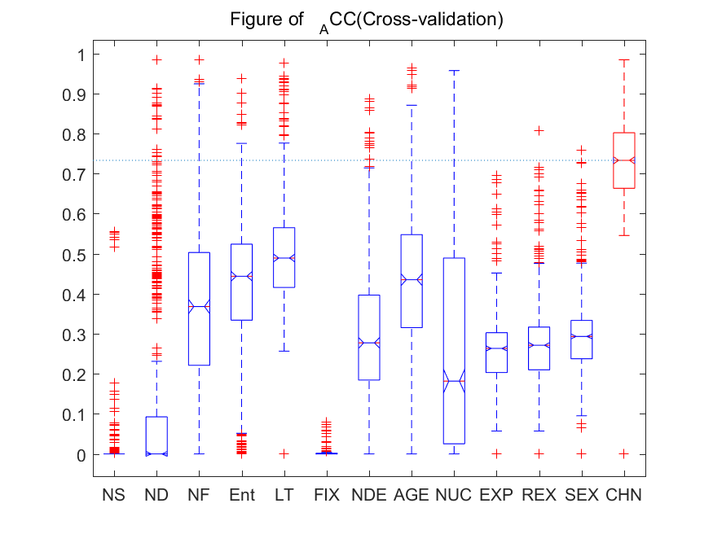
Fig. 4. ACC of six data-sets in 10-fold cross-validation
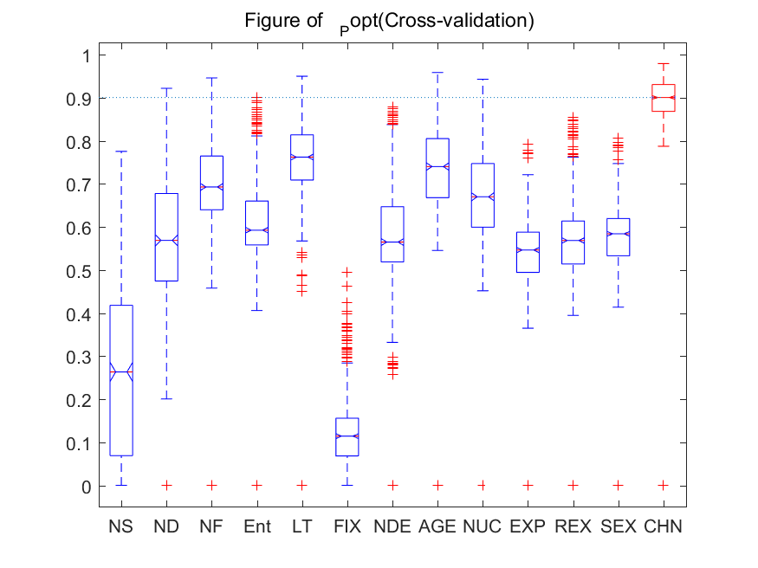
Fig. 5. P_{opt} of six datasets in 10-fold cross-validation
Table VII. Churn vs the state-of-the-art unsupervised models in 10×10 cross validation
Ind | Proj | LT | AGE | Churn
ACC | BUG | 0.476±0.164 | 0.441±0.126 | 0.782±0.049
ACC | COL | 0.590±0.145 | 0.659±0.121 | 0.810±0.080
ACC | JDT | 0.531±0.114 | 0.459±0.138 | 0.719±0.088
ACC | MOZ | 0.367±0.035 | 0.241±0.058 | 0.603±0.024
ACC | PLA | 0.466±0.089 | 0.409±0.110 | 0.749±0.060
ACC | POS | 0.504±0.098 | 0.427±0.111 | 0.705±0.068
Mean |  | 0.489±0.108 | 0.439±0.111 | 0.728±0.061
W/T/L |  | 6/0/0 | 6/0/0 | ―
P_{opt} | BUG | 0.756±0.084 | 0.757±0.063 | 0.930±0.015
P_{opt} | COL | 0.828±0.069 | 0.848±0.053 | 0.937±0.024
P_{opt} | JDT | 0.777±0.060 | 0.744±0.068 | 0.879±0.033
P_{opt} | MOZ | 0.655±0.024 | 0.620±0.029 | 0.813±0.013
P_{opt} | PLA | 0.748±0.052 | 0.715±0.059 | 0.888±0.023
P_{opt} | POS | 0.796±0.05 | 0.751±0.066 | 0.902±0.021
Mean |  | 0.760±0.056 | 0.739±0.056 | 0.891±0.022
W/T/L |  | 6/0/0 | 6/0/0 | ―

Part 2. time-wise cross-validation
In time-wise cross-validataion, Fig. 6 shows the P_{opt} of six data sets, Fig. 7 shows the ACC. From the two figures ,we can see the red box is much higher above than any other boxes. Under the code churn , LT and AGE are followed , that is consistent with Yang's experimental results [9]. The advantage of code churn is still obviously, even no box can reach the media line of code churn , which is draw with horizontal dotted line.
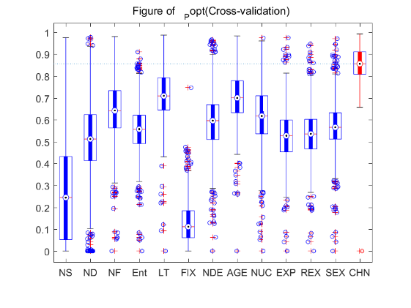
Fig. 6. Popt of six datasets in time-wise cross-validation
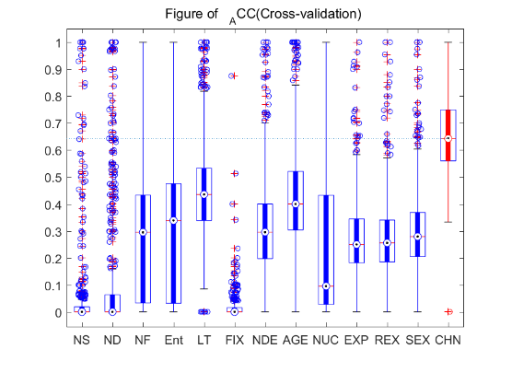
Fig. 7. ACC of six data sets in time-wise cross-validation
Fig 6 and Fig 7 show the general view of time-wise cross-validation . To show more details for each projects, we use the Table VI. In Yang’s study [9], LT and AGE are the best simple unsupervised models , so we compares the result of LT, AGE and code churn of each projects in Table VIII. From the 10 comparison, Code churn has good performance. Comparing with the performance in 10-fold cross-validation, the cliff’s deltas have a certain degree of reduction. For example , with ACC as indicator, in project PostgresSQL, cliff’s delta with LT is 0.4856, with Age is 0.5866, which are very close to medium effectiveness level, while in 10-fold cross-validation, the values are 0.839 and 0.9426.
Comparing with Fu et al.’s OneWay result, from Table IX, we observe that out of all these 12 values of evaluation measures, none of OneWay’s value performs better than code churn. Supervised model lose in effort-aware JIT defect prediction , one more time.

Part 3.across-project
In across-project prediction setting , we compare churn with LT and AGE for the same reason with RQ3’s part2. As shown in Table X, churn continue to be the best model , LT and AGE completely unable to shake its position of being best. We use Lt and Age respectively as benchmark to get the P-value and cliff’s delta. In the total 60 comparisons, code churn makes explanations and words superfluous.
Table VIII. Partial of result of time-wise cross-validation
Ind | Sys | LT | AGE | churn
ACC | BUG | 0.449±0.224 | 0.375±0.275 | 0.697±0.181
ACC | COL | 0.440±0.215 | 0.568±0.18 | 0.720±0.129
ACC | JDT | 0.452±0.131 | 0.408±0.166 | 0.637±0.109
ACC | MOZ | 0.363±0.113 | 0.28±0.167 | 0.582±0.095
ACC | PLA | 0.432±0.168 | 0.429±0.178 | 0.704±0.119
ACC | POS | 0.432±0.221 | 0.426±0.183 | 0.615±0.166
Mean |  | 0.428±0.179 | 0.414±0.192 | 0.659±0.133
W/T/L |  | 6/0/0 | 6/0/0 | ―
Popt | BUG | 0.721±0.165 | 0.661±0.164 | 0.909±0.075
Popt | COL | 0.732±0.146 | 0.786±0.104 | 0.907±0.065
Popt | JDT | 0.709±0.084 | 0.685±0.097 | 0.837±0.052
Popt | MOZ | 0.651±0.07 | 0.638±0.107 | 0.802±0.045
Popt | PLA | 0.717±0.075 | 0.709±0.083 | 0.868±0.050
Popt | POS | 0.742±0.134 | 0.731±0.101 | 0.866±0.079
Mean |  | 0.712±0.112 | 0.702±0.109 | 0.865±0.061
W/T/L |  | 6/0/0 | 6/0/0 | ―
Table IX. Result of comparing code churn with
Fu ET AL’s OneWay
Sys | OneWay |  | Churn
Sys | ACC | popt | ACC | popt
BUG | 0.36 | 0.65 | 0.707 | 0.893
COL | 0.56 | 0.76 | 0.721 | 0.891
JDT | 0.42 | 0.7 | 0.652 | 0.836
MOZ | 0.33 | 0.62 | 0.602 | 0.806
PLA | 0.41 | 0.69 | 0.712 | 0.868
POS | 0.44 | 0.74 | 0.645 | 0.858
Mean | 0.42 | 0.69 | 0.673 | 0.859
p-value | 0.03125 | 0.03125 | ― | ―
Cliff’s δ | 1 | 1 | ― | ―

Table X. The result of across-project
Train | Test | ACC |  |  | Popt
Train | Test | LT | AGE | CHURN | LT | AGE | CHURN
BUG | COL | 0.641 | 0.702 | 0.836 | 0.858 | 0.868 | 0.948
BUG | JDT | 0.582 | 0.490 | 0.761 | 0.815 | 0.769 | 0.897
BUG | MOZ | 0.367 | 0.240 | 0.605 | 0.660 | 0.622 | 0.813
BUG | PLA | 0.494 | 0.427 | 0.774 | 0.770 | 0.740 | 0.899
BUG | POS | 0.533 | 0.432 | 0.726 | 0.810 | 0.762 | 0.908
COL | BUG | 0.435 | 0.432 | 0.790 | 0.726 | 0.758 | 0.932
COL | JDT | 0.582 | 0.490 | 0.761 | 0.815 | 0.769 | 0.897
COL | MOZ | 0.367 | 0.240 | 0.605 | 0.660 | 0.622 | 0.813
COL | PLA | 0.494 | 0.427 | 0.774 | 0.770 | 0.740 | 0.899
COL | POS | 0.533 | 0.432 | 0.726 | 0.810 | 0.762 | 0.908
JDT | BUG | 0.435 | 0.432 | 0.790 | 0.726 | 0.758 | 0.932
JDT | COL | 0.641 | 0.702 | 0.836 | 0.858 | 0.868 | 0.948
JDT | MOZ | 0.367 | 0.240 | 0.605 | 0.660 | 0.622 | 0.813
JDT | PLA | 0.494 | 0.427 | 0.774 | 0.770 | 0.740 | 0.899
JDT | POS | 0.533 | 0.432 | 0.726 | 0.810 | 0.762 | 0.908
MOZ | BUG | 0.435 | 0.432 | 0.790 | 0.726 | 0.758 | 0.932
MOZ | COL | 0.641 | 0.702 | 0.836 | 0.858 | 0.868 | 0.948
MOZ | JDT | 0.582 | 0.490 | 0.761 | 0.815 | 0.769 | 0.897
MOZ | PLA | 0.494 | 0.427 | 0.774 | 0.770 | 0.740 | 0.899
MOZ | POS | 0.533 | 0.432 | 0.726 | 0.810 | 0.762 | 0.908
PLA | BUG | 0.435 | 0.432 | 0.790 | 0.726 | 0.758 | 0.932
PLA | COL | 0.641 | 0.702 | 0.836 | 0.858 | 0.868 | 0.948
PLA | JDT | 0.582 | 0.490 | 0.761 | 0.815 | 0.769 | 0.897
PLA | MOZ | 0.367 | 0.240 | 0.605 | 0.660 | 0.622 | 0.813
PLA | POS | 0.533 | 0.432 | 0.726 | 0.810 | 0.762 | 0.908
POS | BUG | 0.435 | 0.432 | 0.790 | 0.726 | 0.758 | 0.932
POS | COL | 0.641 | 0.702 | 0.836 | 0.858 | 0.868 | 0.948
POS | JDT | 0.582 | 0.490 | 0.761 | 0.815 | 0.769 | 0.897
POS | MOZ | 0.367 | 0.240 | 0.605 | 0.660 | 0.622 | 0.813
POS | PLA | 0.494 | 0.427 | 0.774 | 0.770 | 0.740 | 0.899
Ave |  | 0.509 | 0.454 | 0.749 | 0.773 | 0.753 | 0.900
p-value |  | <0.001 | <0.001 |  | <0.001 | <0.001
Cliff's δ |  | 0.944 | 0.944 |  | 0.889 | 0.944

For the RQ3，the results are very clearly : code churn performs better than any simple unsupervised models and Fu et al.’s OneWay supervised model in effort-aware JIT defect

THREATS TO VALIDITY
We compares the code churn with 3 studies in effect-aware JIT defect prediction with experiments. To get the comparable data, we repeat 2 of the 3 studies’ experiments , and fetch all the consistent data in the same data sets. There maybe three threats to validity our study.
Data setting. Merely conclusion based on six data sets can not escape the suspicion of luck. Hence the greatest threat to validity this study is that our results may not be generalized to other systems.
Performance indicator. About Among the term of indicators, we carry on the same measurement with the comparative studies , although most of the list indicators are focus just a tiny fraction of data, for example, PofB20 just measures cost effectiveness by computing 20% of code lines. Therefore , the second threat to validity is that the indicators is not comprehensive. More calculations ,just like PofB10, are needed.
Prediction setting. In experiment of time-wise cross-validation ,we set a data set with two consecutive months, and the period of two month acts as the gap. All these setting are worth discussing.
To sum up, the unsupervised model of code churn still need more practice.

CONCLUSIONS AND FUTURE WORK
In this paper, we perform an empirical study to investigate the predictive power of the unsupervised model of code churn in effort-aware JIT defect prediction. Our results from six industrial-size systems show that the model perform well in predicting defect-inducing changes. In particular, contrary to the general expectation, we find that effort-aware code churn unsupervised models perform better than the state-of-the-art supervised models reported by Kamei et al. [5] , by Yang et al. [29] , by Fu et al. [32] and better than the state-of-the art simple unsupervised models reported by Yang et al.[9] .In these the comparisons , code churn obtains the obvious advantage. Since code churn model is so effective and substantial in effort JIT defect prediction , however it is not used so far by any JIT study at the same time, is it because it is too easy to ignore it?
Our study only investigates the effect-aware code churn in the in effort-aware JIT defect prediction for open-source software systems. It is unclear whether other effect-aware supervised model can perform better in this field. In the future, an interesting work is hence to extend our current study to effect-aware other supervised model in effort-aware JIT defect prediction, so that we can get a method to synthesize the JIT metrics.

References

- S. Kim, E. Whitehead, and Y. Zhang. Classifying software changes: Clean or buggy. TSE 2008, vol. 34, no. 2, pp. 181–196.
- A. E. Hassan. Predicting faults using the complexity of code changes. ICSE 2009, pp. 78–88.
- A. Meneely, L. Williams, W. Snipes, and J. Osborne. Predicting failures with developer networks and social network analysis. SIGSOFT 2008/FSE 2016, pp. 13–23.
- T. Menzies, Z. Milton, B. Turhan, B. Cukic, Y. Jiang, and A. Bener. Defect prediction from static code features: Current results, limitations, new approaches. ASE 2010, vol. 17, no. 4, pp. 375–407.
- Y.Kamei, E.Shihab, B.Adams, A.E.Hassan, A.Mockus, A.sinha, N.Ubayashi. A large-scale empirical study of just-in-time quality assurance. IEEE Transactions on Software Engineering. 39, 6 (Jun. 2013), 757–773.
- T.Fukushima，Y.Kamei，S.Mcintosh，K Yamashita，N.Ubayashi. 2014. An Empirical Study of Just-in-time Defect Prediction Using Cross-project Models. Proceedings of the 11th Working Conference on Mining Software Repositories (New York, NY, USA, 2014), 172–181.
- N. Bettenburg, M. Nagappan, and A. E. Hassan. Think locally, act globally: Improving defect and effort prediction models. MSR, 2012, pp. 60–69.
- T. L. Graves, A. F. Karr, J. S. Marron, and H. Siy. Predicting fault incidence using software change history. TSE 2000, vol. 26, no. 7, pp. 653–661.
- Y.Yang, Y.Zhou,J.Liu,Y.Zhao,H.Lu,L.Xu, B.Xu, H.Leung. Effort-aware just-in-time defect prediction: Simple unsupervised models could be better than supervised models. Acm Sigsoft International Symposium, 2016:157-168
- N. Nagappan, T. Ball, and A. Zeller, Mining metrics to predict component failures. ICSE 2006, pp. 452–461.
- L. Cheung, R. Roshandel, N. Medvidovic, and L. Golubchik. Early prediction of software component reliability. ICSE 2008, pp. 111–120.
- S. Kim, T. Zimmermann, E. J. Whitehead Jr., and A. Zeller. Predicting faults from cached history. ICSE 2007, pp. 489–498.
- E. Giger, M. D’Ambros, M. Pinzger, and H. C. Gall.Method-level bug prediction. ESEM 2012, pp. 171–180.
- S. Kim, H. Zhang, R. Wu, and L. Gong, Dealing with noise in defect prediction. ICSE 2011, pp. 481–490.
- H. Valpola. Bayesian Ensemble Learning for Nonlinear Factor Analysis. cta Polytechnica Scandinavica. Mathematics and Computing Series No.108, pp. 26-27
- S.Zhong,T.Khoshgoftaar，N.Seliya. Unsupervised learning for expert-based software quality estimation. Eighth IEEE International Symposium on High Assurance Systems Engineering, 2004. Proceedings (Mar. 2004), 149–155.
- K. Herzig, S.Just, A. Zeller. It's not a bug, it's a feature: How misclassification impacts bug prediction. ICSE 2013 , pp. 392-401
- Y. Zhou，B. Xu，H. Leung，L. Chen. An In-depth Study of the Potentially Confounding Effect of Class Size in Fault Prediction. ACM Trans. Softw. Eng. Methodol. 23, 1 (Feb. 2014), 10:1–10:51.
- T.Wang, Z. Zhang, X. Jing, L. Zhang. Multiple kernel ensemble learning for software defect prediction. ASE 2015 , 1–22.
- Mockus, A. and Weiss, D.M. 2000. Predicting risk of software changes. Bell Labs Technical Journal. 5, 2 (Apr. 2000), 169–180.10, pp. 1377–1389.
- J. Liwerski，T. Zimmermann，A. Zeller. 2005. When Do Changes Induce Fixes? Proceedings of the 2005 International Workshop on Mining Software Repositories (New York, NY, USA, 2005), 1–5.
- Z. Yin，D. Yuan，Y. Zhou，S. Pasupathy，L. Bairavasundaram. How Do Fixes Become Bugs? Proceedings of the 19th ACM SIGSOFT Symposium and the 13th European Conference on Foundations of Software Engineering (New York, NY, USA, 2011), 26–36.
- E. Arisholm，LC. Briand，EB. Johannessen. 2010. A systematic and comprehensive investigation of methods to build and evaluate fault prediction models. Journal of Systems and Software. 83, 1 (Jan. 2010), 2–17.
- S. Wang, X. Yao, Using class imbalance learning for software defect prediction, Reliability, IEEE Transactions on 62 (2) (2013) 434–443.
- T. Menzies，Z. Milton，B. Turhan，B. Cukic，Y. Jiang,A.Bener. Defect prediction from static code features: current results, limitations, new approaches. Automated Software Engineering. 17, 4 (Dec. 2010), 375–407.
- X. Yang, D. Lo, X. Xia, Y. Zhang, J. Sun. Deep learning for just-in-time defect prediction. Software Quality, Reliability and Security (QRS), 2015 IEEE International Conference on, IEEE, 2015, pp. 17–26.
- F. Rahman，D. Posnett，P. Devanbu. Recalling the “Imprecision” of Cross-project Defect Prediction. Proceedings of the ACM SIGSOFT 20th International Symposium on the Foundations of Software Engineering (New York, NY, USA, 2012), 61:1–61:11.
- F. Rahman，P. Devanbu. How, and Why, Process Metrics Are Better. Proceedings of the 2013 International Conference on Software Engineering (Piscataway, NJ, USA, 2013), 432–441.
- X.Yang, D.Lo, X.Xia, J. Sun.TLEL: A two-layer ensemble learning approach for just-in-time defect prediction. IST 2017.
- Y. Zhou，B. Xu，H. Leung，L. Chen. An In-depth Study of the Potentially Confounding Effect of Class Size in Fault Prediction. ACM Trans. Softw. Eng. Methodol. 23, 1 (Feb. 2014), 10:1–10:51.
- M. Tan，L. Tan，S. Dara，C. Mayeux. Online defect prediction for imbalanced data. Software Engineering (ICSE), 2015 IEEE/ACM 37th IEEE International Conference .
- W. Fu, T. Menzies. Revisiting Unsupervised Learning for Defect Prediction. FSE 2017.
- Y. Benjamini and Y. Hochberg. Controlling the false discovery rate: a practical and powerful approach to multiple testing. Journal of the royal statistical society. Series B (Methodological) (1995), 289–300
- J. Romano, J. D. Kromrey, J. Coraggio, J. Skowronek, and L. Devine. Exploring methods for evaluating group differences on the NSSE and other surveys: Are the t-test and Cohen.sd indices the most appropriate choices. In annual meeting of the Southern Association for Institutional Research.
- J. Eyolfson，T. Lin，P. Lam. Do Time of Day and Developer Experience Affect Commit Bugginess? Proceedings of the 8th Working Conference on Mining Software Repositories (New York, NY, USA, 2011), 153–162.

